**Azure Synapse:**

Open Microsoft Azure and search for “Azure Synapse Analytics”.

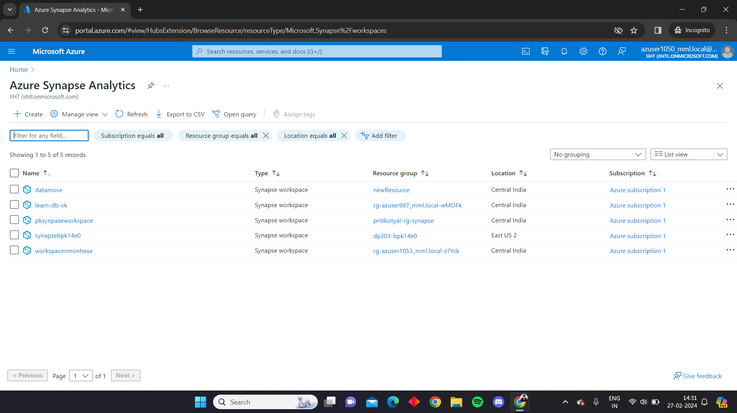

Fill required details and go to review and create

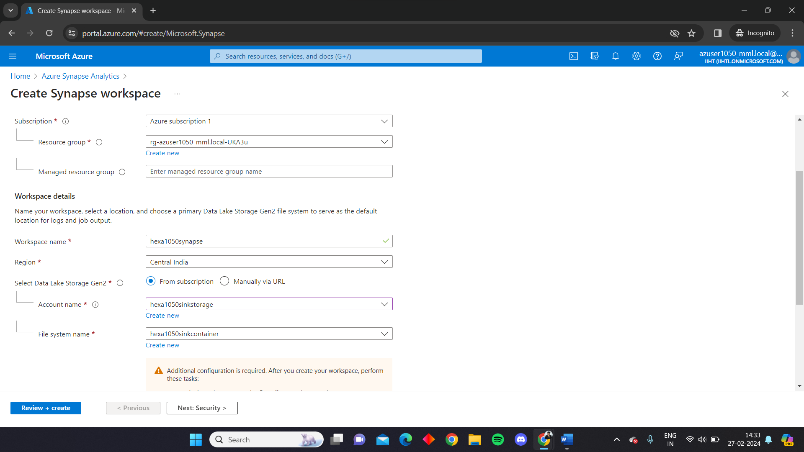

Go to create

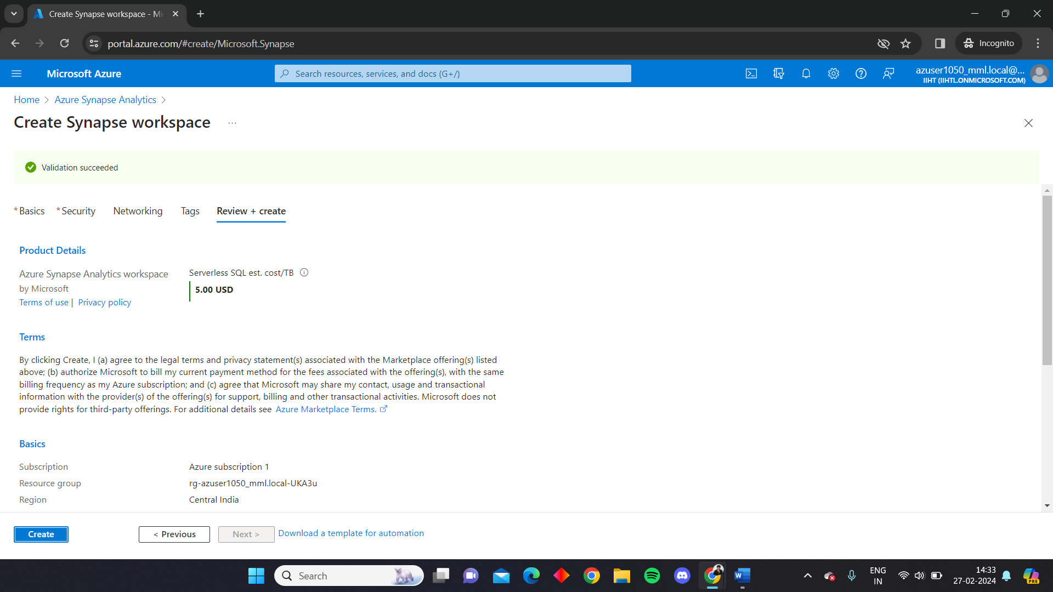

Your Azure Synapse Analytics is being deployed

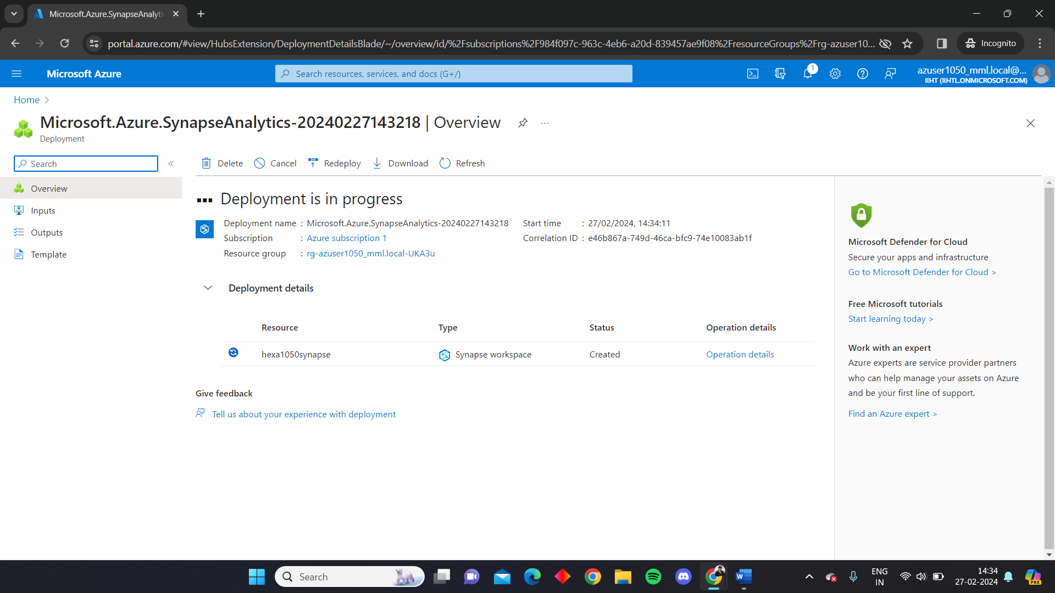

Go to the resources

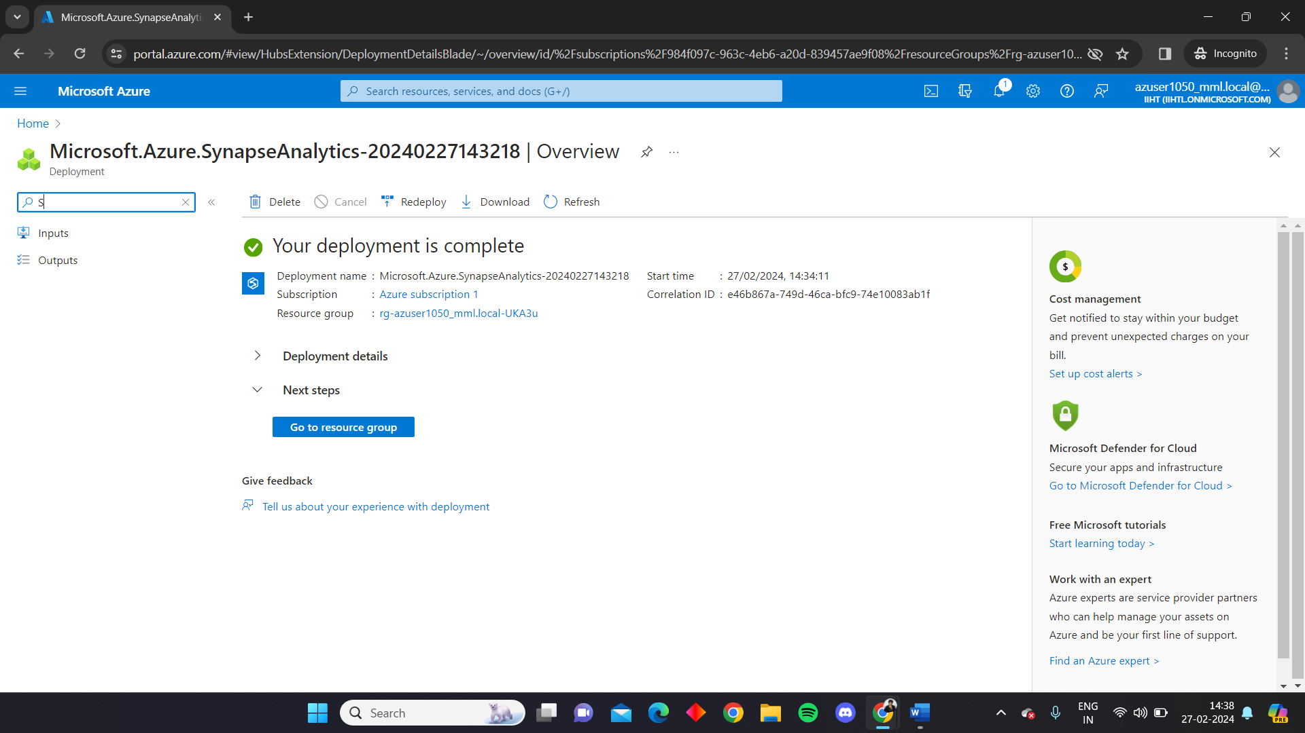

Open Synapse Studio

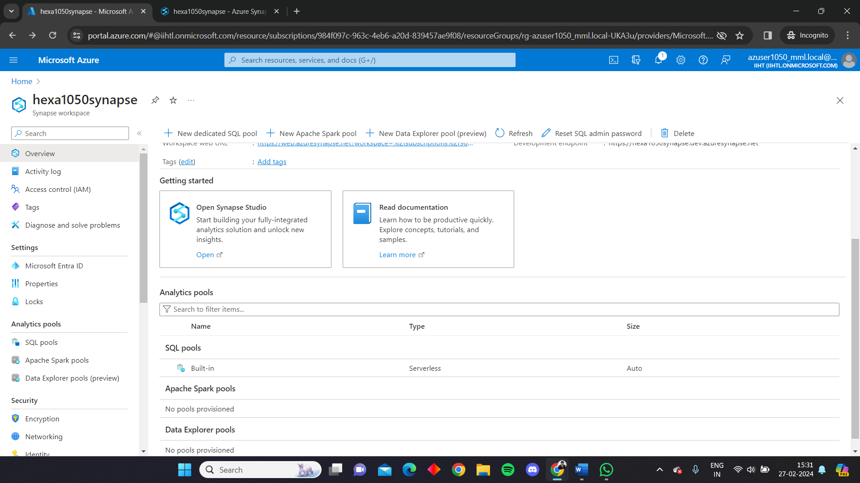

Home page of Azure Synapse Studio

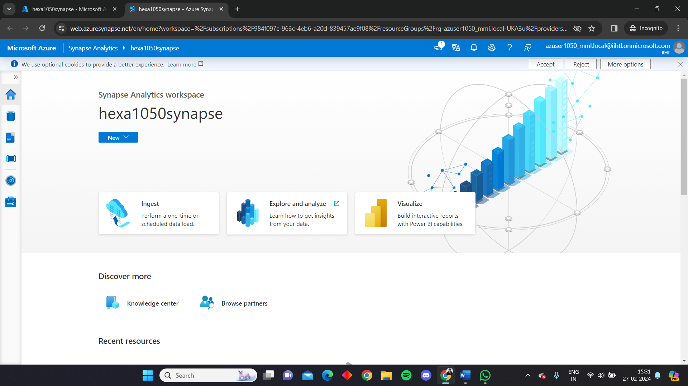

Click on the plus sign and go to Connect to external data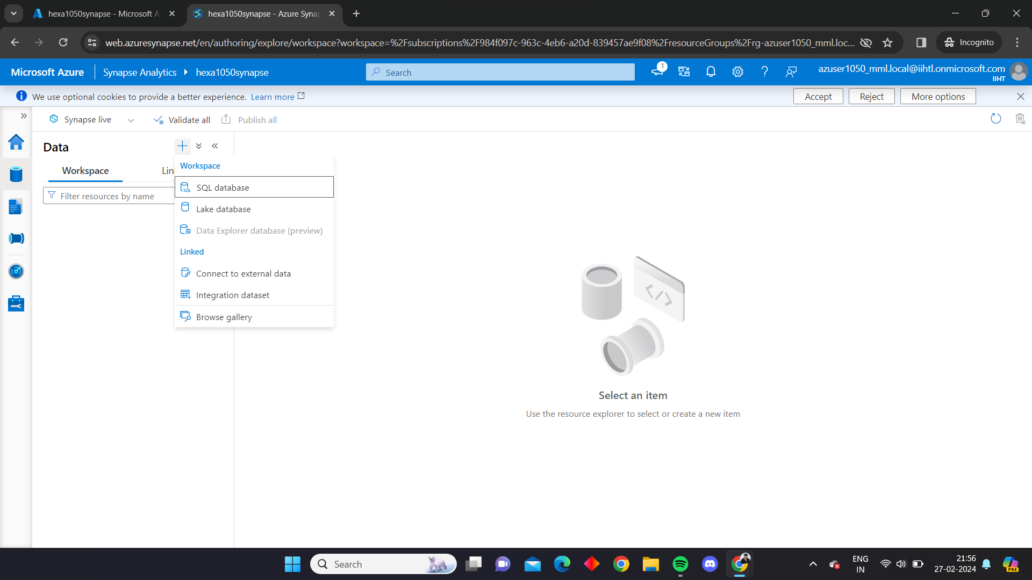

Select Azure Data Lake Storage Gen 2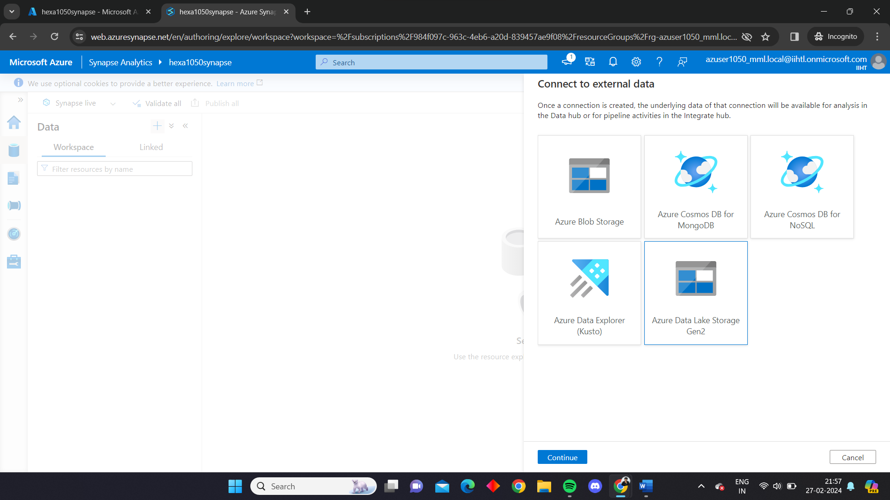

Fill all the required information and click on create

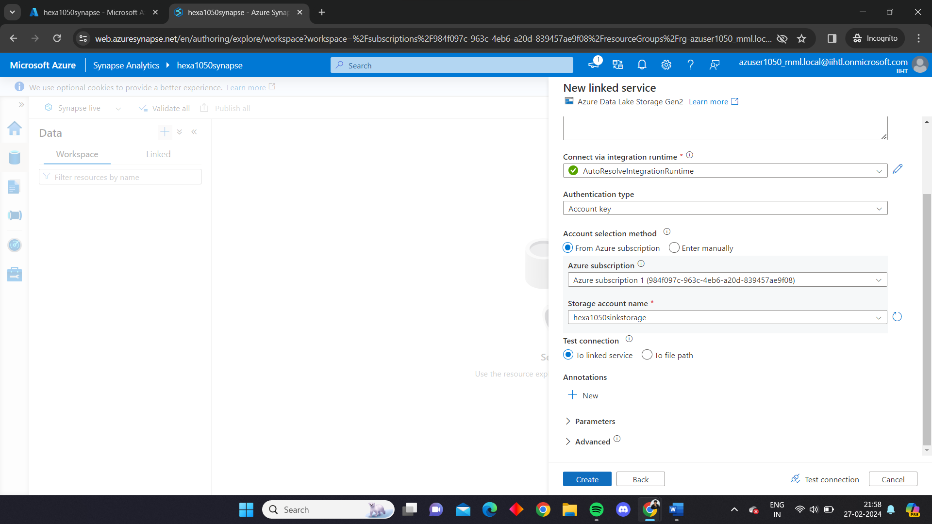

Your ADLS has been successfully linked

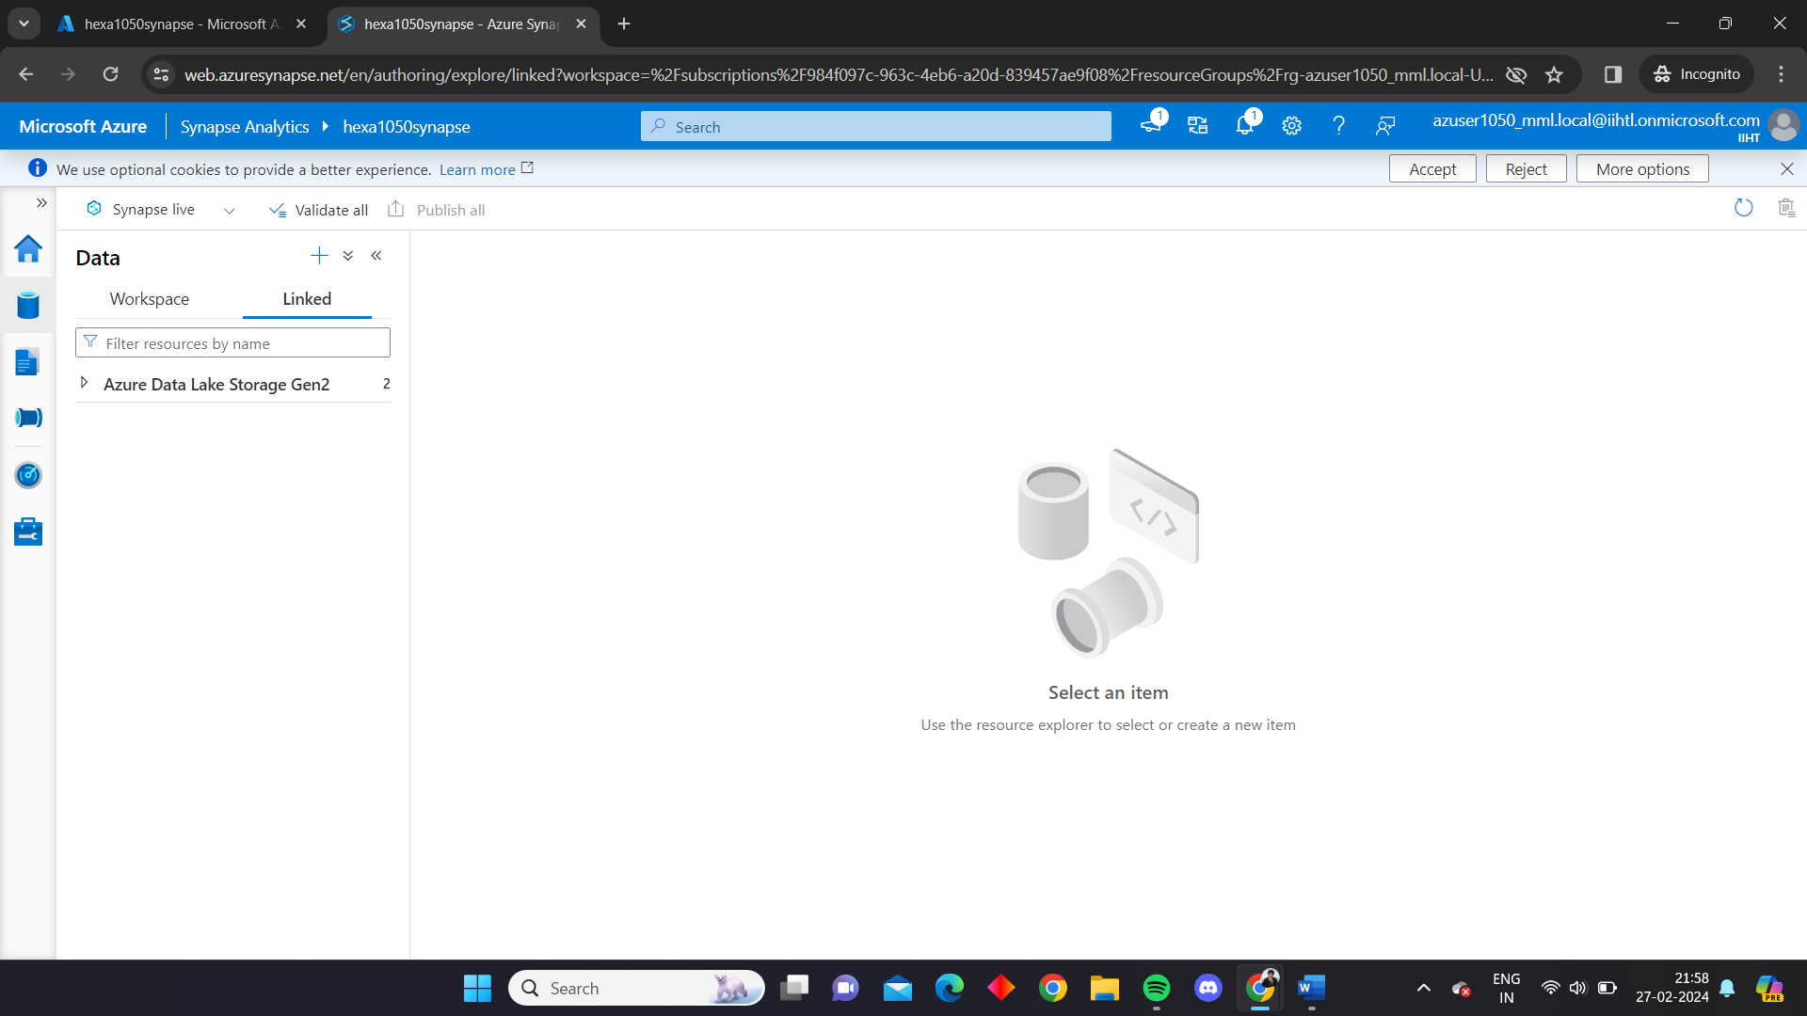

Go to Integrate, and click on the plus sign, go to pipeline.

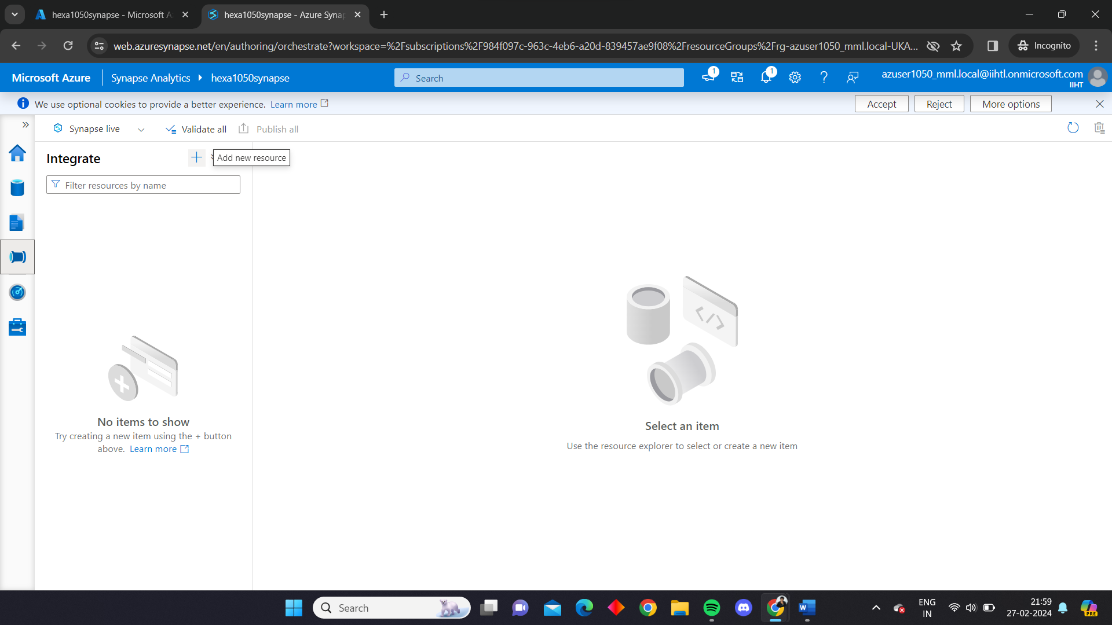

Drag the Copy data activity and then add databricks notebook as activity and fill the required information. Validate the pipeline and publish it.

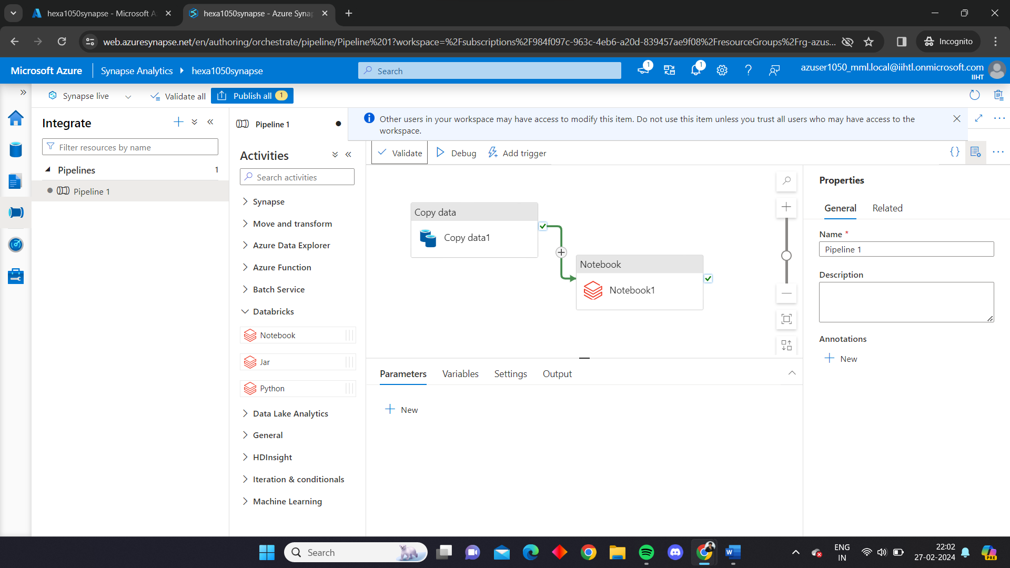

Run the pipeline

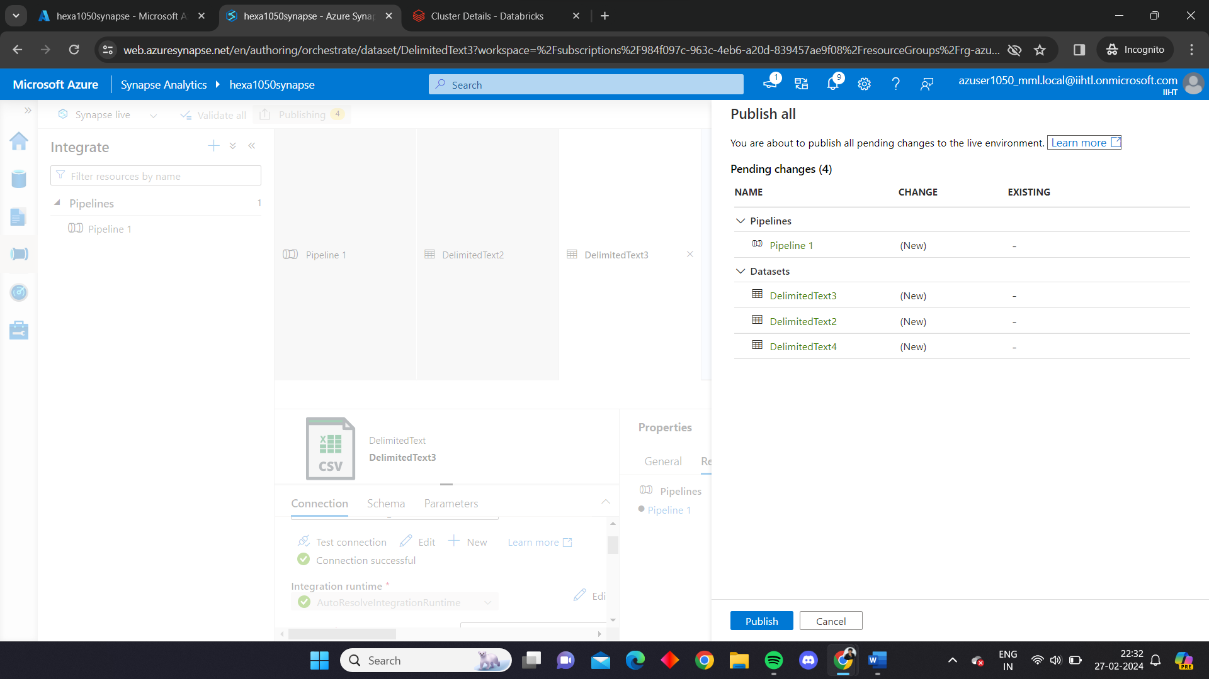

The pipeline ran successfully

